**HandsMen Threads – Salesforce Implementation Project Documentation**

**ABSTRACT**

This project outlines the development and implementation of a customized Salesforce CRM solution for **HandsMen Threads**, a premium men’s fashion and tailoring brand. The primary goal of the project was to streamline core business operations, enhance customer engagement, and ensure data accuracy across various departments.

The solution focused on designing a robust data architecture incorporating key custom objects such as Customer, Order, Product, Inventory, and Marketing Campaigns. Business processes were automated using Record-Triggered Flows, Scheduled Flows, Email Alerts, and Apex to manage order confirmations, loyalty program updates, and proactive stock alerts.

To maintain data accuracy and security, validation rules were enforced, and a role-based security model was implemented for sales, inventory, and marketing teams. The system also utilized scheduled Apex jobs to automate inventory checks and notify low-stock conditions.

This comprehensive CRM deployment not only improved operational efficiency but also elevated the customer experience by delivering personalized communication and data-driven insights. The project establishes a scalable foundation for future expansions and advanced CRM functionalities using the Salesforce platform.

**OBJECTIVE**

The main objective of this project is to design and implement a tailored Salesforce CRM solution for **HandsMen Threads** to streamline business operations, maintain data integrity, and enhance overall customer satisfaction.

By establishing a centralized system to manage **customers, orders, products, inventory, and marketing campaigns**, the project aims to:

* **Automate critical business processes** such as order tracking, discount approvals, and loyalty point updates.
* **Ensure data accuracy and consistency** through validation rules and error-prevention mechanisms.
* **Provide real-time visibility** into sales performance, inventory levels, and customer interactions.
* **Enhance internal collaboration** with role-based access and clear task assignments.
* **Deliver personalized customer experiences** using targeted communications and promotional campaigns.

**TECHNOLOGY**

**Salesforce:**

Salesforce is a cloud-based Customer Relationship Management (CRM) platform that helps businesses manage customer data, automate workflows, and enhance sales, service, and marketing operations. It offers declarative tools (like Flows) and programmatic capabilities (like Apex) to build scalable business solutions.

**Custom Objects:**

Custom Objects in Salesforce are similar to database tables and are used to store specific business data.  
Examples:

* Customer__c – Stores customer information
* Product__c – Stores product details
* Order__c – Tracks customer orders

**Tabs:**

Tabs are used to display object data within Salesforce’s user interface.  
Example: A tab for Product__c allows users to view and manage product records easily.

**Custom App:**

A Salesforce App is a collection of tabs grouped together to support a specific business function.

**Profiles:**

Profiles define what a user can view, edit, or delete within Salesforce. They control access to objects, fields, and permissions.

**Roles:**

Roles determine data visibility based on Salesforce’s role hierarchy. They are used to control access for reporting and sharing.

**Permission Sets:**

Permission Sets provide additional permissions to users without modifying their base profile.

**Validation Rules:**

Validation rules enforce business logic by ensuring data entered meets criteria.  
Examples:

* Email must include “@”
* Stock quantity cannot be negative

**Email Templates:**

Email Templates are predefined formats for sending professional emails.  
Example: *“Order Confirmation”* email template for notifying customers.

**Email Alerts:**

Email Alerts are automated notifications triggered by Flows or Workflow Rules.  
Example: When an order is approved, an email is automatically sent to the customer.

**Flows:**

Flows automate business processes without coding. They can create, update, or notify users automatically.  
Example: A flow sends a reminder email when payment is pending.

**Apex:**

Apex is Salesforce’s programming language used for advanced automation and custom logic.  
Example Triggers:

* Auto-update inventory levels after an order is placed.
* Calculate discounts dynamically based on order quantity.

**DETAILED EXECUTION OF PROJECT PHASES**

**1. Developer Account Creation and Verification**

* Created a developer org in salesforce using

<https://developer.salesforce.com/signup>

* Verified account through email activation and completed login setup.

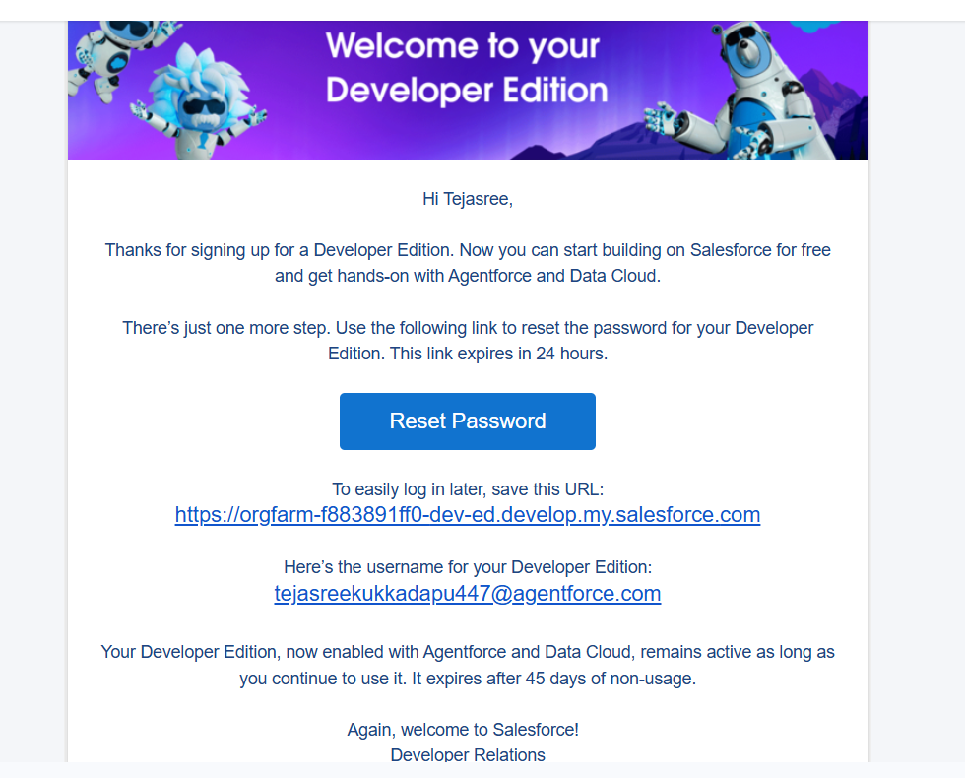

**2. Data Management - Object Creation**

Created five custom objects to manage key business data:

* **HandsMen Customer:** Stores customer details.
* **HandsMen Product:** Stores product catalog details like SKU, price, and stock.
* **HandsMen Order:** Manages order records linked to customers and products.
* **Inventory:** Maintains product stock levels and availability.
* **Marketing Campaign:** Tracks campaigns, leads, and customer engagement.

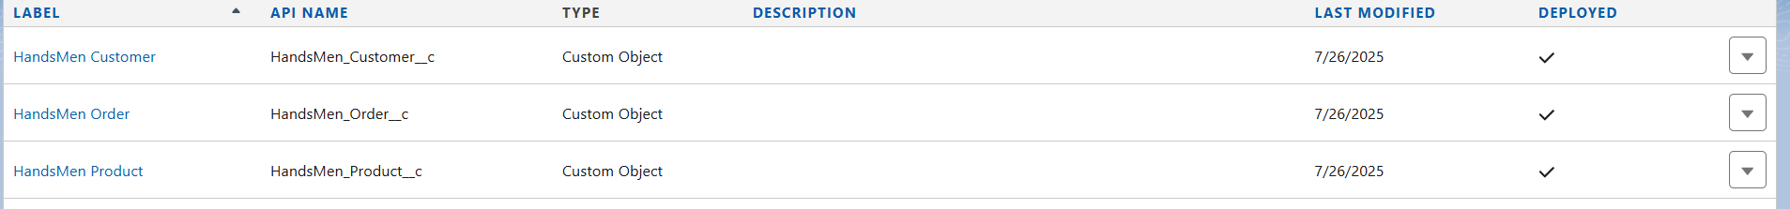

 

**3. Tab Creation**

* Created **custom tabs** for objects (e.g., HandsMen Customer Tab) to allow easy navigation and record management.
* Added tabs to the **Salesforce Navigation Bar** for user accessibility.

**4. App Creation - HandsMen Threads**

* Built a **custom app** named "HandsMen Threads" that grouped all relevant tabs (Customer, Product, Orders, Inventory, Campaigns).
* Customized branding with app logo and navigation order.

**5. Field Creation**

* Added custom fields in **HandsMen Customer:**
  + **Email (Text)**
  + **Phone (Number)**
  + **Loyalty Status (Picklist: Silver, Gold, Platinum)**
* Created additional fields in other objects:
  + **Order Amount, Product Price, Stock Quantity, Campaign Budget, etc.**

**6. Validation Rules**

To ensure accurate data entry and enforce business logic, the following validation rules were applied:

* **Order Object:** Prevents saving if Total_Amount_c0.
* **Error:** "Please Enter Correct Amount"
* **Customer Object:** Validates email contains @gmail.com.
* **Error:** "Please fill Correct Gmail

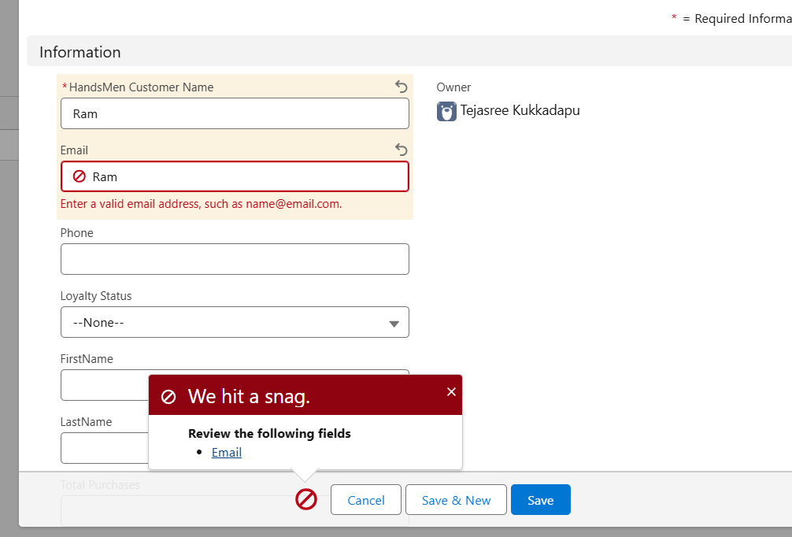

**7. Profile & Role Setup**

* Created **Sales Profile** with restricted access to configuration and admin features.
* Defined **Sales Role** to control record visibility using hierarchy.

**8. User Creation**

* Created user accounts:
  + **Niklaus** (Sales Profile, Sales Role).
  + **Kol** (Sales Profile, Sales Role).



**9. Email Templates and Alerts**

* Created templates for:
  + **Order Confirmation** – Auto-sent to customers after order creation.
  + **Stock Alert** – Sent to warehouse team for low stock.
  + **Loyalty Status Update** – Sent to customers for loyalty upgrades.
* Email Alerts:

Configured **Email Alerts** to trigger order confirmation and stock notifications automatically.

**10. Flows**

* **Record-Triggered Flow:** Sends stock alert email when quantity drops below threshold.
* **Scheduled Flow:** Runs daily to notify low inventory items.

**11. Apex Development**

* **Apex Triggers:**
  + **Update Order Total (Order__c):** Automatically updates the **Total_Amount__c** field when an order is saved.
  + **Stock Deduction (Inventory__c):** Reduces stock quantity in the inventory when an order is placed.
  + **Loyalty Status Update (Customer__c):** Upgrades the customer’s loyalty status based on purchase history.
* **Apex Class:**  
  Automates loyalty discount calculations for high-tier customers during order creation.
* **Batch Apex:**  
  Runs nightly updates to recalculate loyalty points and clear old marketing campaign records.

**12. Testing and Validation**

* Performed object, automation, and Apex testing using sample data.
* Conducted **UAT** with users Niklaus and Kol to validate workflows.

**Project Explanation with Real-World Example**

The **HandsMen Threads Salesforce CRM Project** digitizes and automates core business processes for managing customers, orders, inventory, and marketing campaigns. By centralizing data and automating workflows, it reduces manual effort, improves efficiency, and enhances the customer experience.

**Real-World Example:**

* A customer named **Alex** places an order for three shirts.
* **Order Creation:** The order is entered into Salesforce and automatically linked to Alex's customer record.
* **Order Total Update:** An **Apex Trigger** calculates the total price based on quantity and product price.
* **Stock Deduction:** The inventory automatically reduces the stock count for shirts using another trigger.
* **Email Automation:** Alex receives an automated **Order Confirmation Email Template** immediately.
* **Loyalty Points Update:** Once the order is delivered, loyalty points are added, and Alex’s status upgrades from *Gold* to *Platinum* via **Batch Apex**.
* **Stock Alert Flow:** If stock falls below the threshold after Alex's purchase, an email alert is sent to the inventory manager to reorder items.

This automated process eliminates manual tracking, ensures accurate data updates, and provides timely customer communication, ultimately improving satisfaction and operational efficiency.

**SCREENSHOTS**

Fig:Custom app for HandsMen Threads

Fig: Customer Creation in HandsMen Threads

Fig: Products in HandsMen Threads

Fig: Order details

**Conclusion**

* The **HandsMen Threads Salesforce CRM Project** successfully streamlined customer, order, inventory, and campaign management into a single platform.
* Automation using **Apex Triggers, Flows, and Email Alerts** reduced manual work and minimized errors.
* Real-time dashboards and reports improved decision-making for sales and inventory teams.
* Loyalty programs and personalized email templates enhanced customer engagement and retention.
* Overall, the project improved operational efficiency, increased customer satisfaction, and laid a strong foundation for scalable business growth.

**Future Scope**

* **E-Commerce Integration:** Connect Salesforce with platforms like Shopify or Magento for real-time order synchronization.
* **AI and Einstein Analytics:** Implement predictive analytics for sales forecasting and customer purchase recommendations.
* **Mobile App Access:** Provide sales teams with mobile access to manage leads, orders, and inventory on the go.
* **Service Cloud Integration:** Add case management and chatbots for improved after-sales customer support.
* **Loyalty Program Enhancements:** Automate reward tiers with AI-driven offers based on buying behavior.
* **Multi-Currency and Multi-Language Support:** Prepare for international expansion and global customer management.